Goodbye Campus

Capstone Design II



Team : 3-Idiots

20132697 | Jaewon Lee

20141226 | Hyunwoo Park

20143583 | Kihwan Kim

**1. Introduction**

Every year, many CSE senior students graduate our university. But, there are always lots of students who suffer from graduation or even can’t graduate on time because they don’t know the exact requirements and regulations. Just by looking at my colleague's group chat room, there are lots of friends like them. There are actually several obstacles that make it difficult to know the rules.

Confusion of graduation

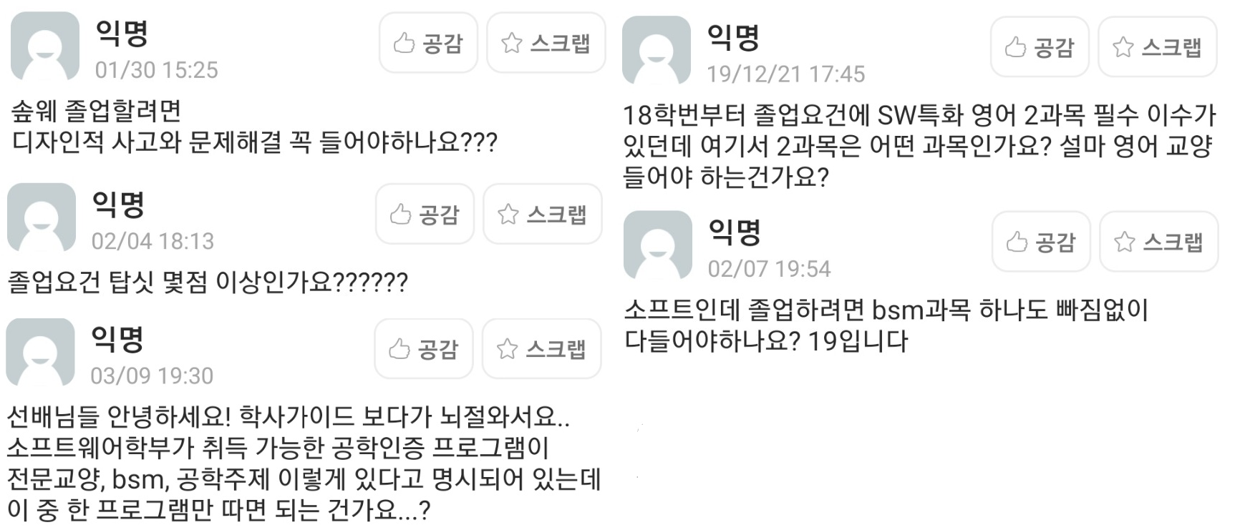

On university department website, school rules are written in lengthy way. So, its readability is so poor. Even if I scan all the regulation carefully, I couldn’t get a certainty that I am right or not.

In addition to normal rules that we have to meet, there are also other things that we must satisfy such as ABEEK or regular 4 times meeting with their academic advisor. It definitely aggravates confusion.

Currently, there are two CAU web pages that shows information about student’s own graduation. But there is an error on it. Two pages say the same thing but show us different result.

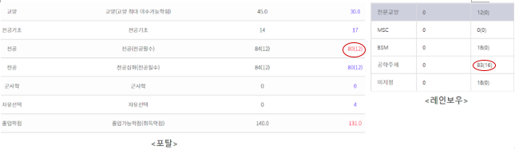

Also, it is really easy to be derailed if you take a wrong course even in their first year in university. In the worst case, they should delay their graduation because of the course they should have taken but they don’t. To make matter worse, there are high probability that vacant seat of these course which typically only for the certain grade may not be available for other grade students.

Even though there is a department that helps student about their graduation, it is really hard to ask trivial things to them. So our program is definitely required.

2. Goal of the Project

**1) Offer accurate information to users**

Our program is designed to reduce confusion. It must be able to check exact requirement that students need to meet. We are going to test this by making up virtual 20 student cases that probably exist in reality with varying their total credits or whether they’ve done 4 times consultation with their advisor or not and check the accuracy. We aim to achieve 100% accuracy.

**2) Time of processing**

Our program needs crawling users’ course information that they have taken from CAU portal after they give us their ID and password. We expect that this process takes some time. Considering that our program is a chat program, we need to lower the time taken. So our goal is to reduce the time between users’ questions and bots’ answers to 5 seconds at most.

**3) Human language Understanding**

We intend our program to understand human language well so that let the user feel comfortable while conversing with our chat bot.

**4) Easy to deal with change of curriculum**

We will try to make our program easy to deal with shift of curriculum by implementing admin mode. With this mode, when there is modification of graduation requirements, we will help someone easy to edit our program according to those changes. Before we will graduate, we will do this administration job, but after we graduate if this program become popular, then we will ask to our department office to manage this system.

**5) Deal with substitute subjects**

There must be elimination of course or addition of course. Also, there is the same course with different name and different course code. To treat this, we will try to crawl substitute course list from CAU portal. If we can't get those DB, then we will ask to CAUCSE department office for asking it. When new substitute course added in the future, then, it could be added in this program by using admin mode of our program.

3. Theoretical Basis

**NLP(Natural Language Processing)**

* Using NLP for processing users’ request.
* Making answer sentences with NLP

**Web Crawling, Web token and encryption**

* Get ID and password with secure way from user.
* Get a token access for CAU portal.
* Get users’ course information from web site.

**Server Deployment**

* Deploy server that can run our bot
* Construct DB (CAUCSE courses, Graduation requirements)

**Frontend**

* Make user friendly UI/UX

4. Project Description

**4.1) Explanation of project**

The most important function is to check whether the student can graduate or not. That is, if users ask our program if they can graduate, it will check requirements about graduation and judge whether they meet the conditions or not. For instance, if someone may ask ‘Can I graduate?’ or ‘Can I get out of university?’, our program will find they are the same meaning and give him the same answer.

Also, we will make the AI chatbot which answer questions about graduation such as ‘How many BSM credits should I take?’, ‘Do I have to take this subject as a mandatory course? ’, etc. To achieve this, our application should identify the questions by NLP, check proper item on the school regulations, and answer it to users.

**4.2) Explanation of Development**

- Graduation Judgement

Graduation judgement is the main function of our program. To do this, We will ask users’ ID & password and identify if they satisfy graduation requirements according to department regulations. If they met the terms, our chatbot tell them ‘Congratulation! You can graduate!’. If not, it tells them they can’t graduate and shows them the conditions they’re not satisfied with.

- Answering Questions Related with Graduation

Answering users’ questions is also important function of our program since so many students are confused by the complicated rules of the course. Our program is supposed to get the meaning of the question by NLP and shows the terms and regulations which they wanted to know on the portal or CSE website using crawling method

- Scenario Testing

To know that our application is working well and satisfy users’ needs, we will make about 20 scenarios of students and test the program using these test information. Through this process, we can easily check if it works as we designed and know where to make up for

- Admin mode

To deal with change of curriculum and substitute course, we will design admin mode to edit those things.

- Extension to the Outside (Future work)

We are willing to expand this project not just our department but also other departments, even more, other universities because these problems occur in places other than our department.

- Github Activities (https://github.com/ljwon1995/GoodbyeCampus)

We will make lots of commits with detail commit messages and update all commits we do on this Github. We will communicate with others via this Github on Issues board and if others pull requests on our project, we will consider thoroughly and decide whether commit or not. Based on the fact that our program is only for the CAUCSE students in this semester, mostly we will ask CAUCSE students to use our program and ask them to leave issues mainly who is 4th grade but not in this class. Also, we have couple of friends who majors in CSE also, but in different University. We will also ask them to use our apps, thinking that they might give us useful advice on GUI or in the aspects of ease of use.

5. Design and Implementation of Project

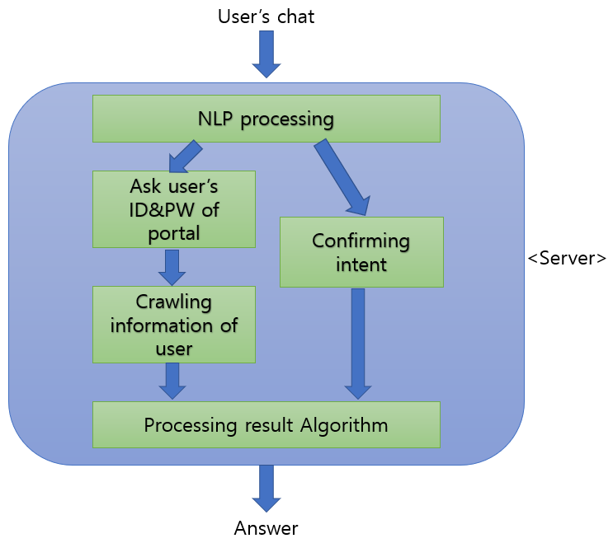

**NLP Processing and Create Chatbot (Jaewon Lee)**

Using open source software ChatScript which enables us to make chat bot and NLP easily, we will make a chatbot that is fit for our purpose. Training our bot with diverse form of sentences. When the bot get messages from users it will realize users’ intent and entity of the messages. Then, if the intent requires ID & PW, ask users again.

**ID & PW Encryption (Kihwan Kim)**

After getting ID & PW from users, we need to encrypt it for security. With encrypted ID and password, we will log in to CAU portal.

**Crawling Information (Jaewon Lee)**

After log in CAU portal, we need to crawl information that we need for processing the result.

**Result Processing Algorithm (Hyeonwoo park)**

With the information we get, we need to check whether user is able to graduate or not. If not, we will make a string dialogue what is required for graduation.

**Frontend (Kihwan Kim)**

Make a web page that looks like chat room with React. Also make a admin web page.

**Backend (Hyeonwoo Park)**

Deploy server with Django where our agent will be run.

**Admin Mode (Kihwan Kim)**

Make an admin mode algorithm.

**Testing Tool (Jaewon Lee)**

In testing time, we couldn’t get multiple portal ID. So we will build an environment for testing. With input csv files that says all courses virtual student took, it will determine possibility of graduation.

6. Time Schedule

Jaewon Lee

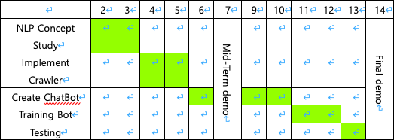

Kihwan Kim

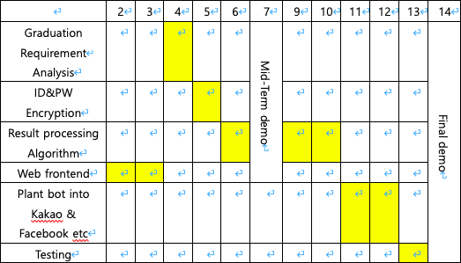

Hyeonwoo Park

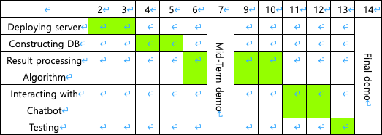

7. References

Use of open software

React

* For implementing front part, we will use React open source software
* https://github.com/facebook/react

Django

* For implementing server part, we will use Django open source software
* https://github.com/django/django

ChatScript

* For implementing our own chat bot, we will use ChatScript
* <https://github.com/ChatScript/ChatScript>

Crawler

* We will refer and modify this software to build in our own crawler
* <https://github.com/paywteam/cau-timetable-scraper>

Chatbot reference document

<https://www.chatbotkorea.com/magazine/4>

Chatbot/NLP Information

https://github.com/hyunjun/bookmarks/blob/master/nlp.md